# Catch-22

[Andrew Schulz](mailto:aschulz6@uncc.edu), [Lutou Xiong](mailto:lxiong13@uncc.edu), [Kevin Hang](mailto:khang2@uncc.edu), [Irzem Ahmed](mailto:mahmed29@uncc.edu)

# Part A:

(2 points) What are some ethical considerations of your product?

-Public

-Client and employer

-Product

-Colleagues

(2 points) Address any features in your product that could be misused and how you plan to guard against misuse. *For example, if you plan to allow images to be uploaded by users, will you include a way for other users to report inappropriate images or use some other strategy?*

-Images

-Language(curse words)

Allow users to report other users and add text filters.

# Part B:

1. As a team decide on a tool (e.g, google slides, powerpoint, moqups.com, draw.io, justinmind.com,...) to use for creating mockup prototypes of the user interfaces.

2. Design the pages for your app as Lo-Fi UIs using any tool. At a minimum your pages should support the following features:

* + The main app homepage
  + Viewing a list of projects/tasks stored in the application database
  + Viewing a project/task and their details
  + Entering data for a project/task
  + Editing data for a project/post
  + Commenting on a project/task
  + User registration
  + User sign in (login)

3. Create a storyboard with your pages by adding arrows from one page to another to show the path from one page to another. **Note:** Google slides will allow you to paste images and then draw arrows and other images.

* + Paste a screenshot of your final storyboard into this section of your project document.

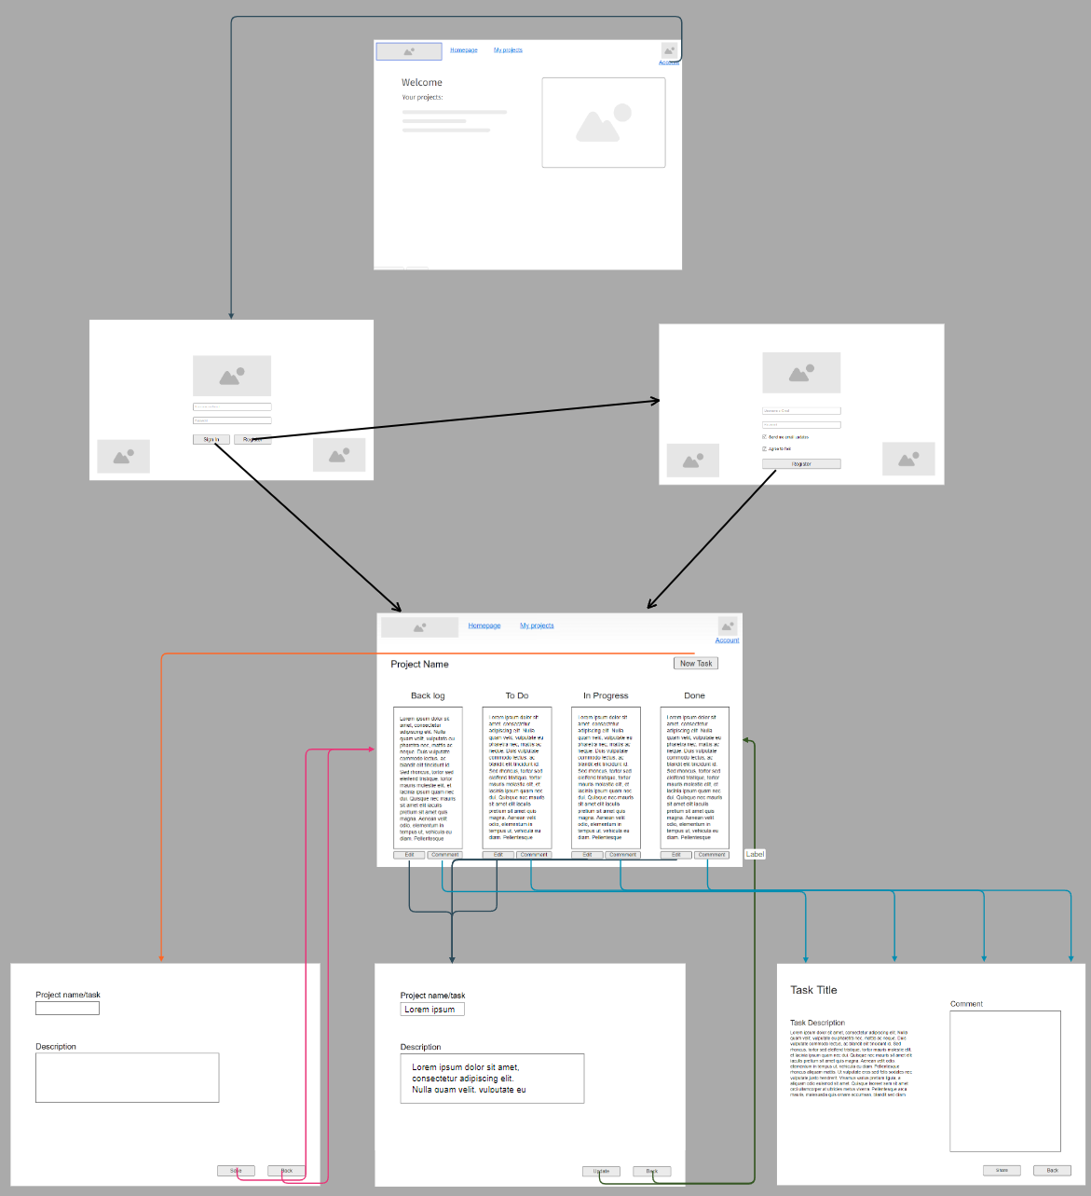

# Part C:

Update your product backlog to reflect the current status of your project and include a screenshot in your project document.

